**WEB TECHNOLOGIES**

**LAB CYCLE-1:**

**1.**

* Create a web page having the background in green and title “My First Page”

|  |  |
| --- | --- |
|  | SOURCE CODE:  <html> |
|  | <head><title>lab1.1.a</title></head> |
|  | <body bgcolor="#00cc00"> |
|  | My First Page. |
|  | </body> |
|  | </html> |

OUTPUT:

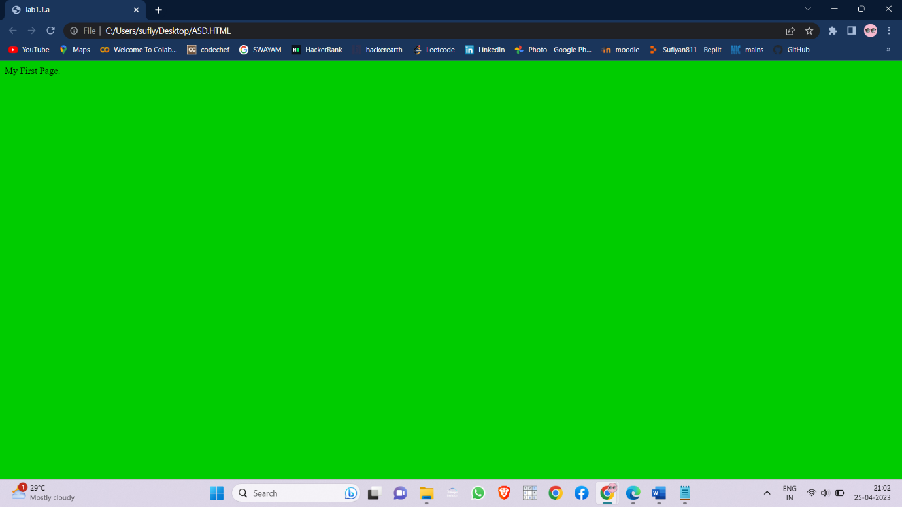

* Create a web page of pink colour and display a moving message in red colour.

SOURCE CODE:

<html>

<head><title>lab1.1.b</title></head>

<body>

<font color="#ff0000">

<marquee behavior="alternate" direction="right" hspace="20%">Ok Fine.</marquee>

</font>

</body>

</html>

OUTPUT:

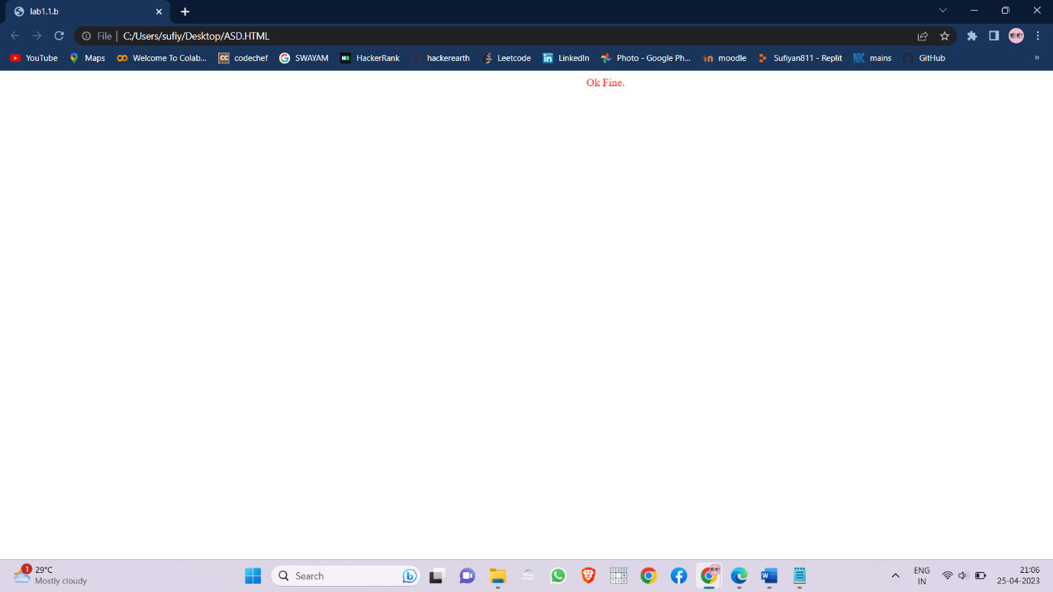

* Design a web page containing text, in form of paragraphs giving suitable heading style

SOURCE CODE:

<html>

<head><title>lab1.1.c</title></head>

<body>

<font size="15"><b>Deforestation</b></font><br>

<font size="5">Deforestation is the purposeful clearing of forested land. Throughout history and <br>into modern times, forests have been razed to make space for agriculture and<br> animal grazing, and to obtain wood for fuel, manufacturing, and construction.</font>

<font size="11"><b><br>Slash-and-burn agriculture</b></font><br>

<font size="5">Slash-and-burn agriculture is a big contributor to deforestation in the tropics.<br> With this agricultural method, farmers burn large swaths of forest, allowing<br>the ash to fertilize the land for crops.</font>

<font size="8"><b><br>Cause</b></font><br>

<font size="5">Direct causes of deforestation are agricultural expansion, wood extraction<br>(e.g., logging or wood harvest for domestic fuel or charcoal), and infrastructure<br>expansion such as road building and urbanization</font>

</body>

</html>

OUTPUT:

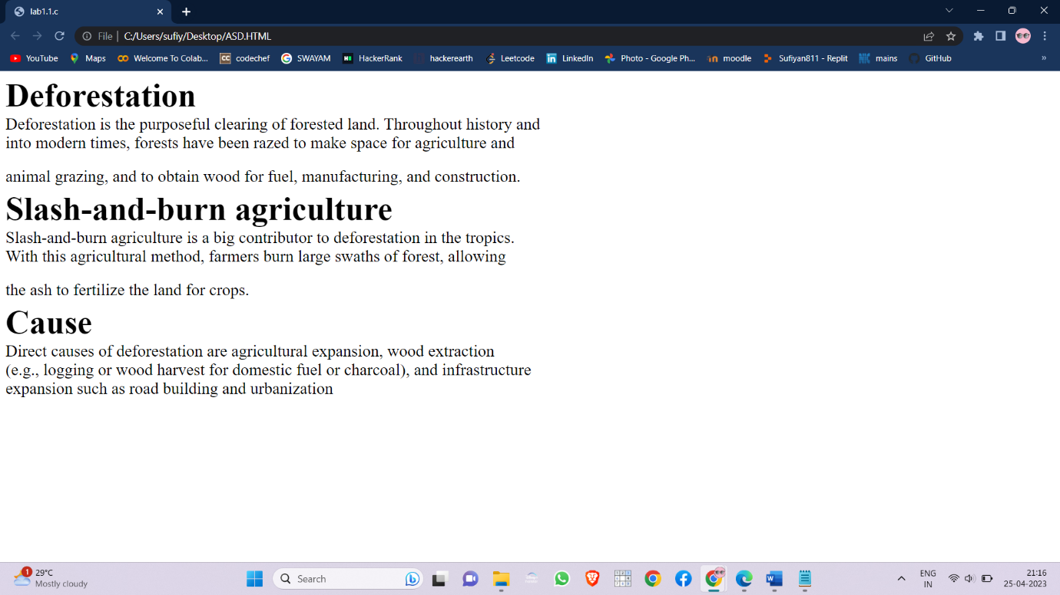

2.

* Create a web page which displays WELCOME text using heading tags(h1 to h6)

SOURCE CODE:

<html>

<head><title>lab1.2.a</title></head>

<body>

<center>

<h1>WELCOME</h1><br>

<h2>WELCOME</h2><br>

<h3>WELCOME</h3><br>

<h4>WELCOME</h4><br>

<h5>WELCOME</h5><br>

<h6>WELCOME</h6><br>

</center>

</body>

</html>

OUTPUT:

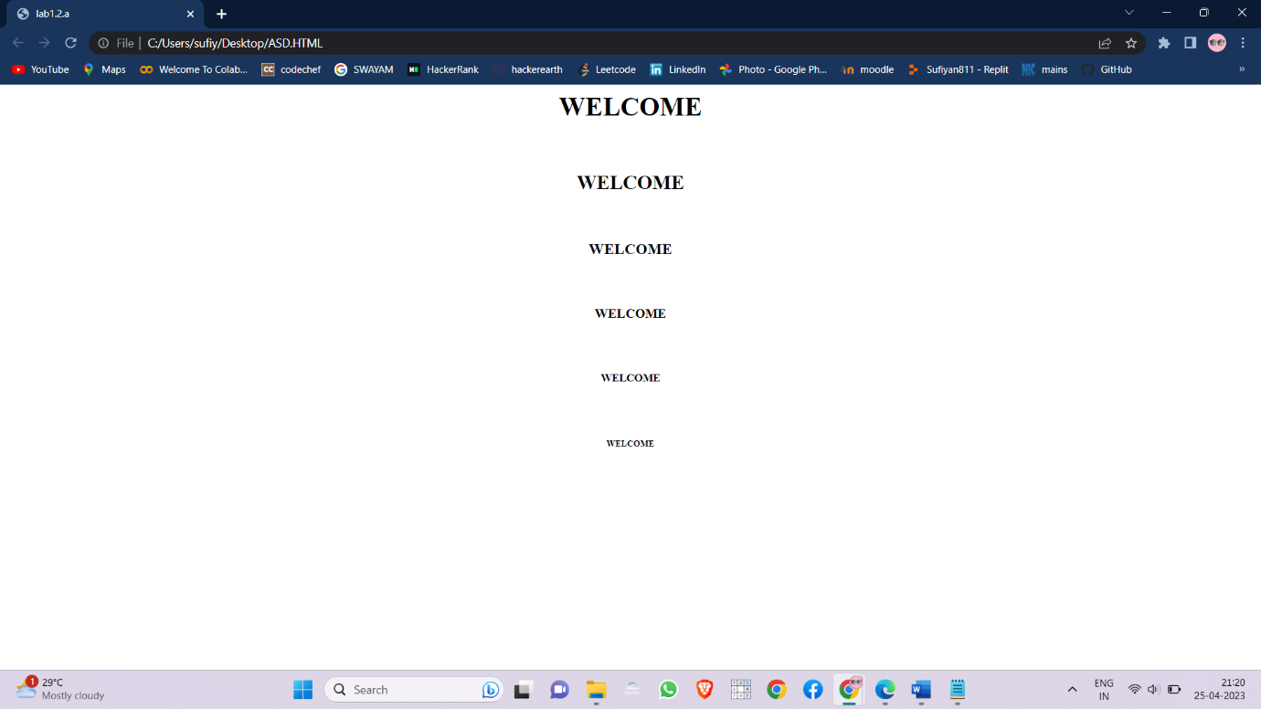

* Create a web page which displays WELCOME text using tag.

SOURCE CODE:

<html>

<head><title>lab1.2.b</title></head>

<body>

<center><b>WELCOME<b></center>

</body>

</html>

OUTPUT:

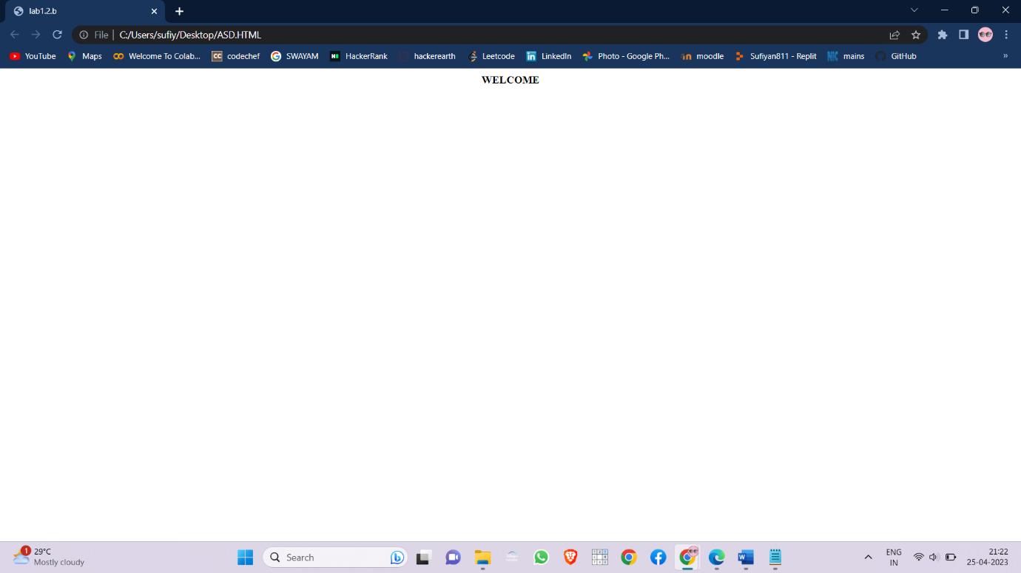

* Create a web page which displays h2o and x2+y2 using <sub> tag and <sup> tag.

SOURCE CODE:

<html>

<head><title>lab1.2.c</title></head>

<body>

WATER = h<sub>2</sub>o<br>

EQUATION = x<sup>2</sup> + y<sup>2</sup>

</body>

</html>

OUTPUT:

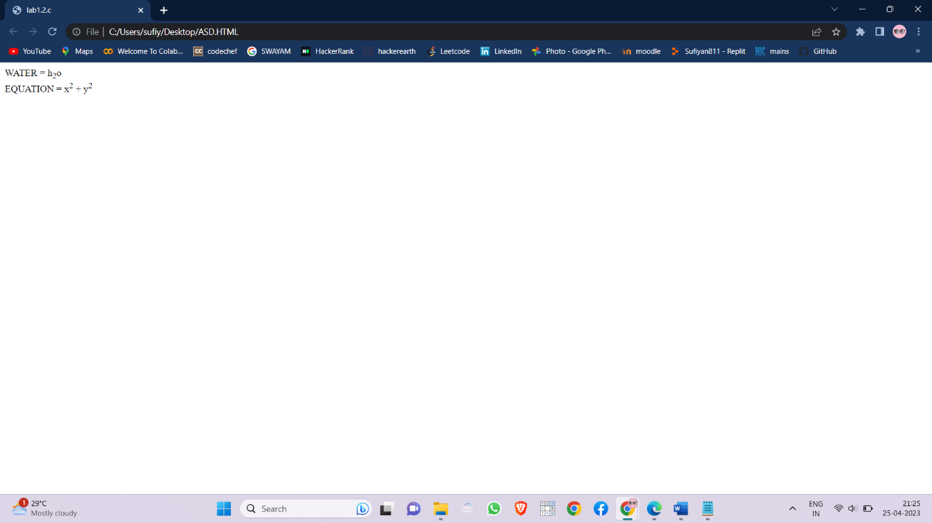

* Create a web page to show different attributes of Font tag.

SOURCE CODE:

<html>

<head><title>lab1.3.a</title></head>

<body>

<font color="red" size="20" face="Jokerman">There you go</font>

</body>

</html>

OUTPUT:

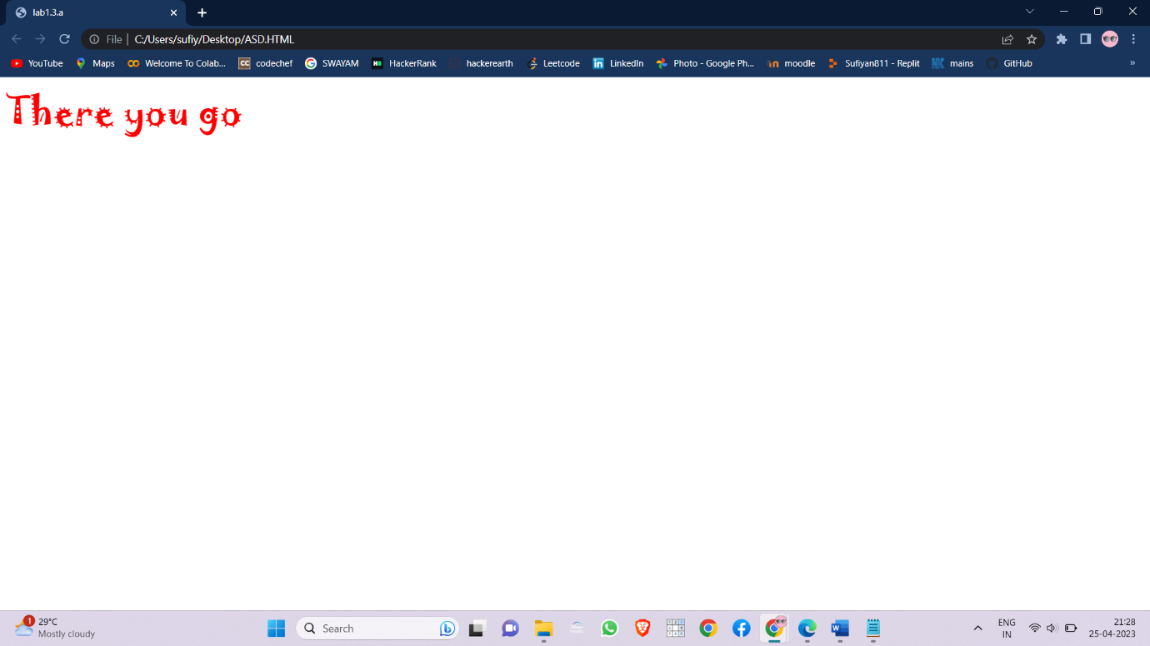

* Create a web page to show different attributes: italics, bold, underline.

SOURCE CODE:

<html>

<head><title>lab1.3.b</title></head>

<body>

<center><b>Never do it<b><br>

<i>If you dont</i><br>

<U>want to</u>

</center>

</body>

</html>

OUTPUT:

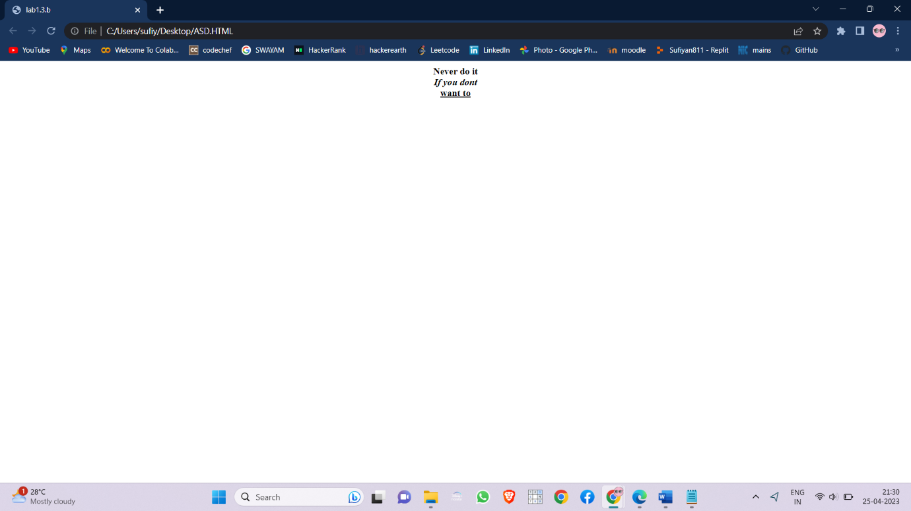

* Design a web page having background colour yellow and giving text colour red

SOURCE CODE:

<html>

<head><title>lab1.3.c</title></head>

<body bgcolor="#ffff00">

<font color="#ff0000">Always go for it.</font>

</body>

</html>

OUTPUT:

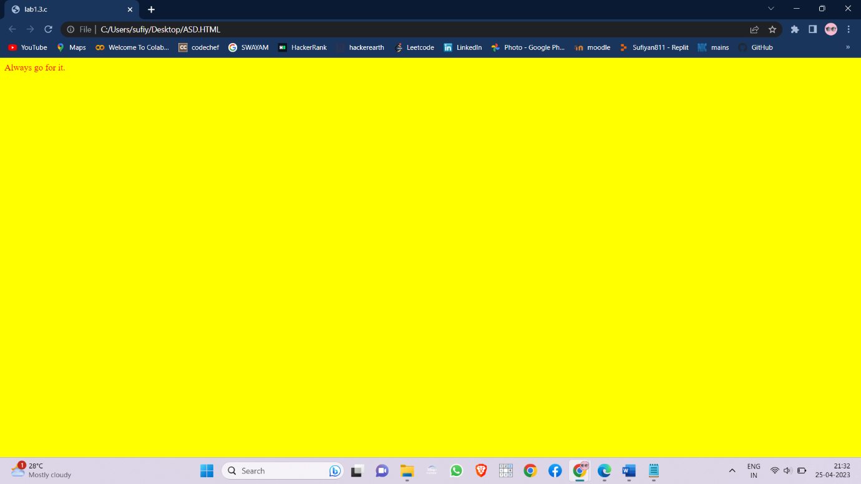

* Create a web page using href attribute of anchor tag & the attribute: alink, vlink etc.

SOURCE CODE:

<html>

<head><title>lab1.4.a</title></head>

<body bgcolor="snow" vlink="green">

<center>

<a href="https://google.com" alt="Page is not responding">Google</a>

&emsp;<a href="https://facebook.com" alt="Page is not opening">Facebook</a>

</center>

</body>

</html>

OUTPUT:

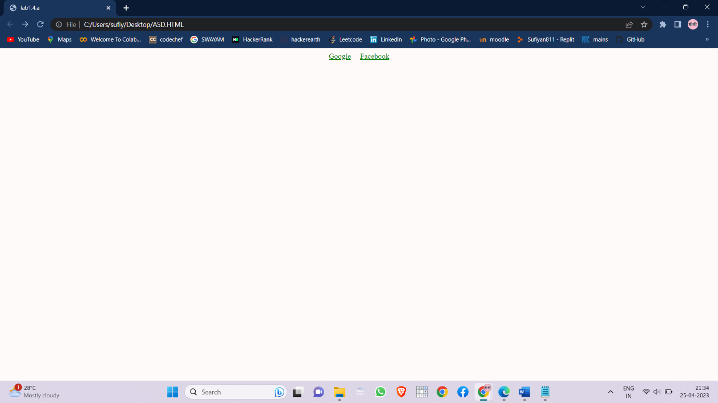

* Create links on the words e.g. ―Wi-Fi and ―LAN‖ to link them to Wikipedia pages.

SOURCE CODE:

<html>

<head><title>lab1.4.b</title></head>

<body>

<i>Click on link if you want to visit</i><br>

1.<a href="https://en.wikipedia.org/wiki/Wi-Fi">Wi-Fi</a><br>

2.<a

href="https://en.wikipedia.org/wiki/Local_area_network">

LAN</a><br>

3.<a href="https://en.wikipedia.org/wiki/Wireless_LAN#:~:text=A%20wireless%20LAN%20(WLAN)%20is,%2C%20campus%2C%20or%20office%20building.">WLAN</a>

</body>

</html>

OUTPUT:

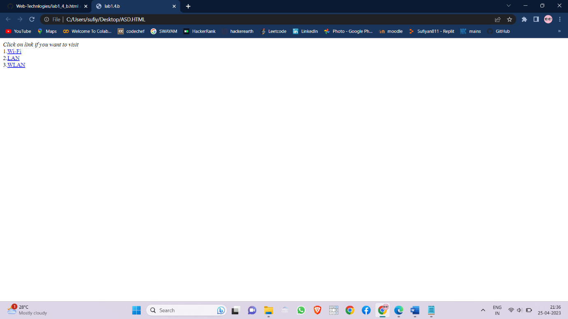

* Create a web page with appropriate content and insert an image towards the left hand side of the page. When user clicks on the image, it should open another Web page.

SOURCE CODE:

<html>

<head><title>lab1.4.c</title></head>

<body bgcolor="Lightgreen">

<center>

<font color="red" size="10">RVR & JC College Of Engineering</font><br>

<a href="https://rvrjcce.ac.in/"><img align="left" src="rvr.jpg" width="40%" height="50%"></a>

<a href="https://rvrjcce.ac.in/placement_statistics.php?menu=plcmnt"><img align="right" src="placements.jpg" width="40%" height="50%"></a>

</center>

</body>

</html>

OUTPUT:

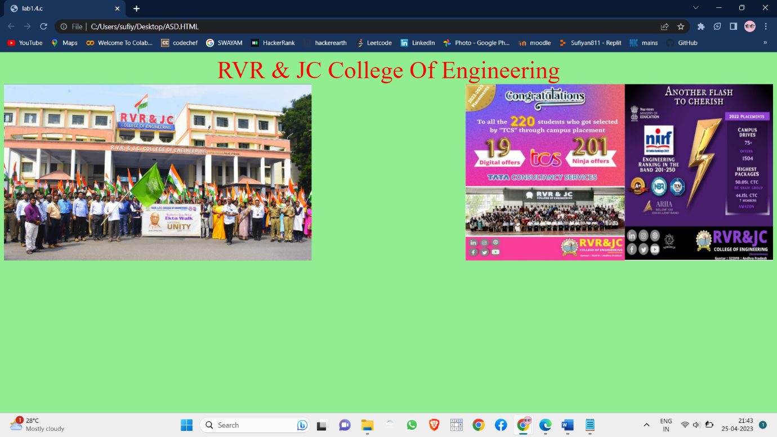

* Create a web page, showing an ordered list of the names of five of your friends.

SOURCE CODE:

<html>

<head><title>lab1.5.1</title></head>

<body>

<font color="red" size="5">&emsp;Friends :</font>

<ol>

<li>Shreyas</li>

<li>Karthik</li>

<li>Sathish</li>

<li>Neeraj</li>

<li>Tayyab</li>

<li>Roshan</li>

</ol>

</body>

</html>

OUTPUT:

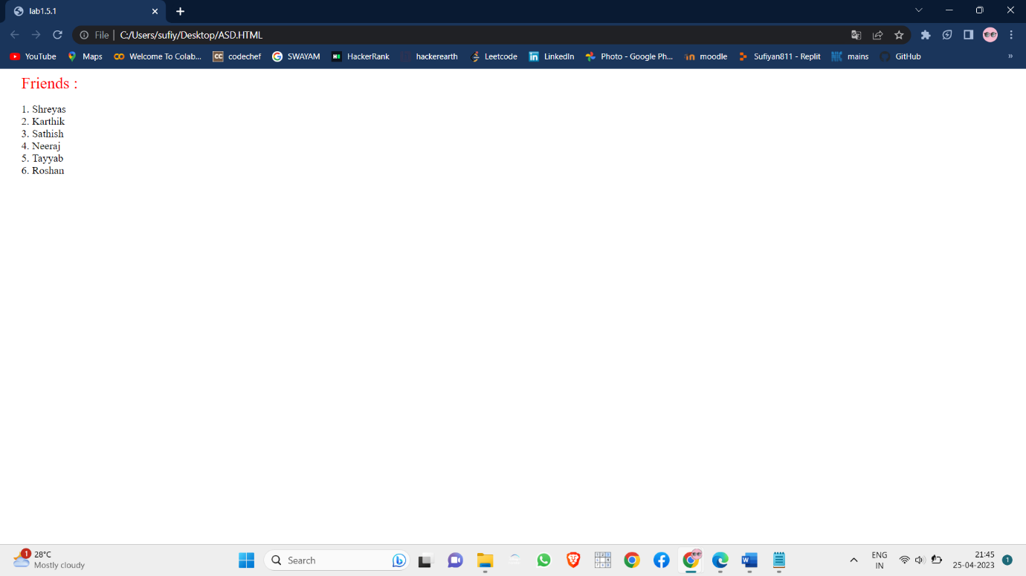

* Create a web page containing a nested list showing the content page of any book

SOURCE CODE:

<html>

<head><title>lab1.5.2</title></head>

<body>

<font color="red" size="5">Effective Writing</font>

<ol>

<li>Write a Head-Turning Headline.

<ol><li>The headline</li>

<li>Walker Sands’</li></ol>

</li>

<li>Create a Hook That Grabs Their Attention.

<ol><li>You have three</li>

<li>plays in determining whether they read</li></ol>

</li>

<li>Do Your Research.

<ol><li>You must have extensive</li>

<li>statistics, data and metrics</li></ol>

</li>

<li>Focus on a Single Purpose.

<ol><li>You should</li>

<li>write and tie your content.</li></ol>

</li>

</ol>

</body>

</html>

OUTPUT:

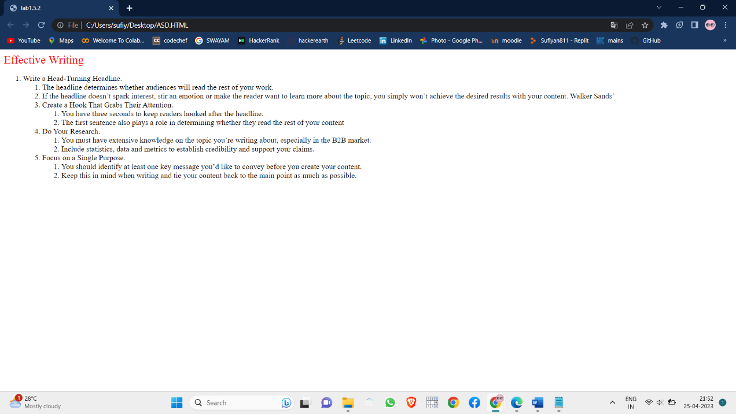

* Create a web page, showing an unordered list of names of five of your friends

SOURCE CODE:

<html>

<head><title>lab1.5.3</title></head>

<body>

<font color="red" size="5">&emsp;Friends :</font>

<ul>

<li>Shreyas</li>

<li>Karthik</li>

<li>Sathish</li>

<li>Neeraj</li>

<li>Tayyab</li>

<li>Roshan</li>

</ul>

</body>

</html>

OUTPUT:

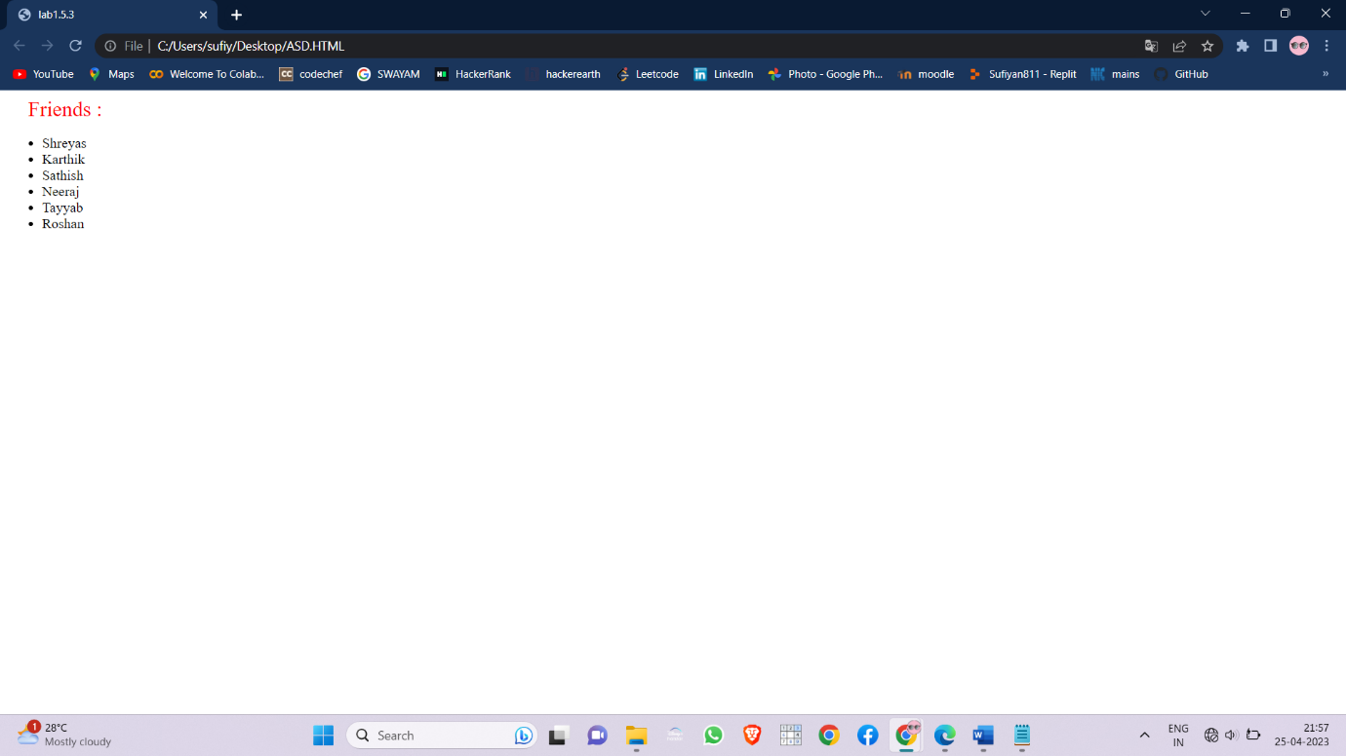

* Create a table to show your class timetable using rowspan and colspan attributes.

SOURCE CODE:

<html>

<head><title>Web Technologies</title>

</head>

<body bgcolor:"AliceBlue">

<font size="6">

<center><b><u>COMPUTER SCIENCE<br>SECTION-C</u></b>

</font>

<br><br><br><b><font size="5"><u>Time-Table</b></center></font></u><br>

<table bgcolor="white" border="2" align="center">

<tr style="height:50px">

<th>Time/Day</th>

<th>8:00 -9:00</th>

<th>9:00 -10:00</th>

<th>10:00 -11:00</th>

<th>11:00 -12:00</th>

<th>12:00 -1:00</th>

<th>1:00 -2:00</th>

<th>2:00 -3:00</th>

</tr>

<tr>

<th>MON</th>

<td>E&H</td>

<td>CS</td>

<td>DBMS</td>

<th rowspan="6">L<br>U<br>N<br>C<br>H</th>

<td>OS</td>

<td>WT</td>

<td>SE</td>

</tr>

<tr>

<th>TUE</th>

<td>OS</td>

<td>WT</td>

<td>CS</td>

<td colspan="3"> WT LAB(ACC) </td>

</tr>

<tr>

<th>WED</th>

<td colspan="3"> DBMS LAB(ACC) </td>

<td>CS</td>

<td>SE</td>

<td>DBMS</td>

</tr>

<tr>

<th>THU</th>

<td colspan="2"> SOC LAB(E-Learning) </td>

<td>WT</td>

<td>DBMS</td>

<td>SE</td>

<td>E&H</td>

</tr>

<tr>

<th>FRI</th>

<td>SOC</td>

<td>OS</td>

<td>WT</td>

<td colspan="3"> CS LAB(ACC) </td>

</tr>

<tr>

<th>SAT</th>

<td colspan="2"> CC LAB(E-Learning) </td>

<td>SOC</td>

<td>OS</td>

<td>CS</td>

<td>DBMS</td>

</tr>

</table>

</body>

</html>

OUTPUT:

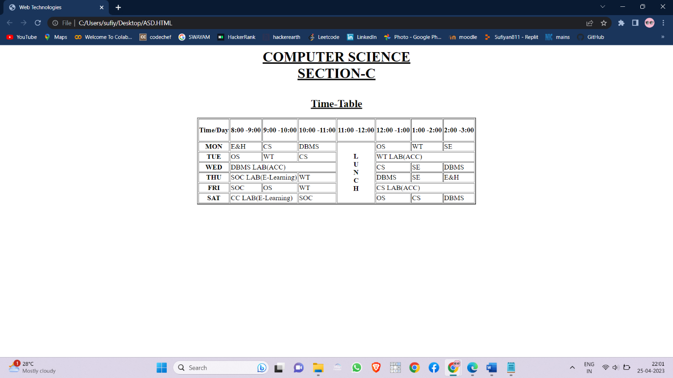

* Use tables to provide layout to your HTML page describing your college infrastructure.

SOURCE CODE:

<html>

<head><title>lab1.6.b</title></head>

<body>

<table border="2" align="center">

<tr>

<td><img src="college.jpg" alt="RVR & JC" height="200" width="200" ></td>

<th>Courses</th> <th>Blocks</th>

<th>Libraries</th> <th>Computer Labs</th>

<th>Physics Lab</th> <th>Chemistry Lab</th>

<th>PlayGrounds</th> <th>Buses</th>

<th>Faculty</th>

</tr>

<tr>

<td>RVR & JC </td> <td>12</td>

<td>6</td> <td>7</td>

<td>21</td> <td>1</td>

<td>2</td> <td>2</td>

<td>14</td> <td>250</td>

</tr>

</body>

</html>

OUTPUT:

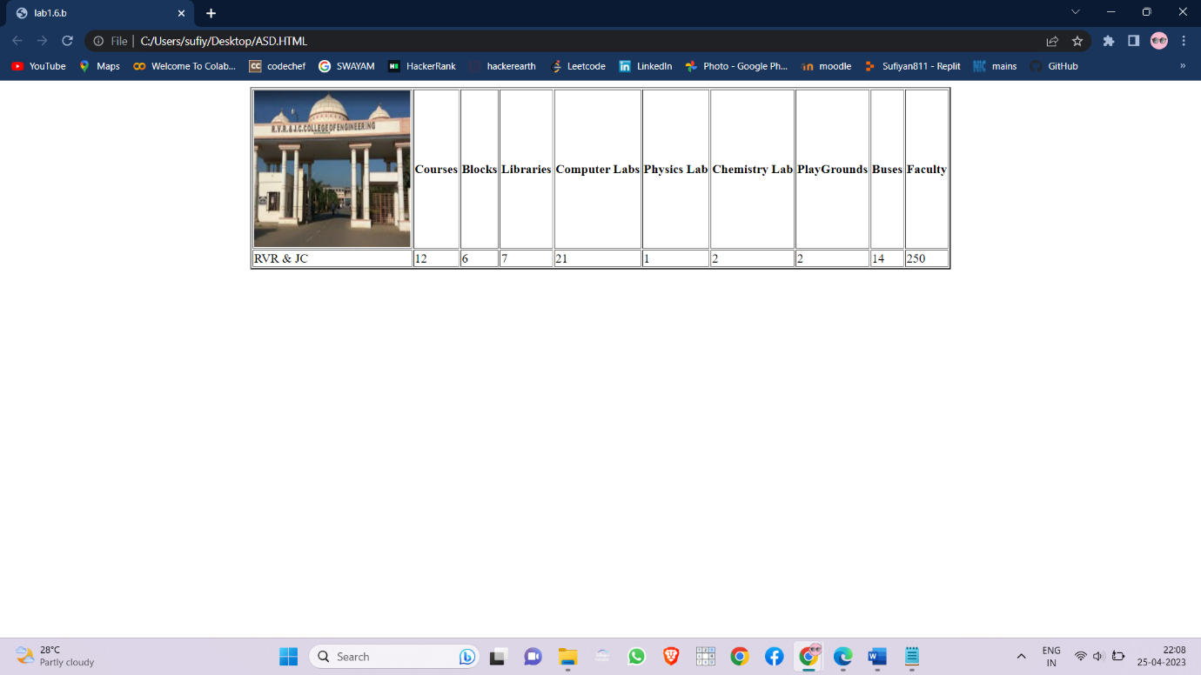

* Create a web page in the following table fields

SOURCE CODE:

<html>

<head><title>lab1.6.3</title></head>

<body>

<table align="center" border="1">

<tr>

<th rowspan="2">&ensp;Name of train&ensp;</th>

<th rowspan="2">&ensp;Place&ensp;</th>

<th rowspan="2">&ensp;Destination&ensp;</th>

<th rowspan="2">&ensp;Train No&ensp;</th>

<td colspan="2"><b><center>Time</center></th>

<th rowspan="2">&ensp;Fare&ensp;</th>

</tr>

<tr>

<th>Arrival</th>

<th>Departure</th>

</tr>

<tr>

<td>Palaknamadas</td>

<td>Guntur</td>

<td>Tirupati</td>

<td>12085</td>

<td>4:00</td>

<td>5:00</td>

<td>Rs.270</td>

</tr>

<tr>

<td>shatbdhi express</td>

<td>Guntur</td>

<td>Hyderabad</td>

<td>18056</td>

<td>8:00</td>

<td>18:00</td>

<td>Rs.150</td>

</tr>

<tr>

<td>chennai express</td>

<td>vijaywada</td>

<td>chennai</td>

<td>16673</td>

<td>4:00</td>

<td>7:00</td>

<td>Rs.1270</td>

</tr>

<tr>

<td>Golkonda Express</td>

<td>Golkonda</td>

<td>Hyderabad</td>

<td>78640</td>

<td>9:00</td>

<td>23:00</td>

<td>Rs.360</td>

</tr>

<tr>

<td>Tirupati Express</td>

<td>Vijaywada</td>

<td>Tirupati</td>

<td>19876</td>

<td>16:00</td>

<td>4:00</td>

<td>Rs.670</td>

</tr>

</table>

</body>

</html>

OUTPUT:

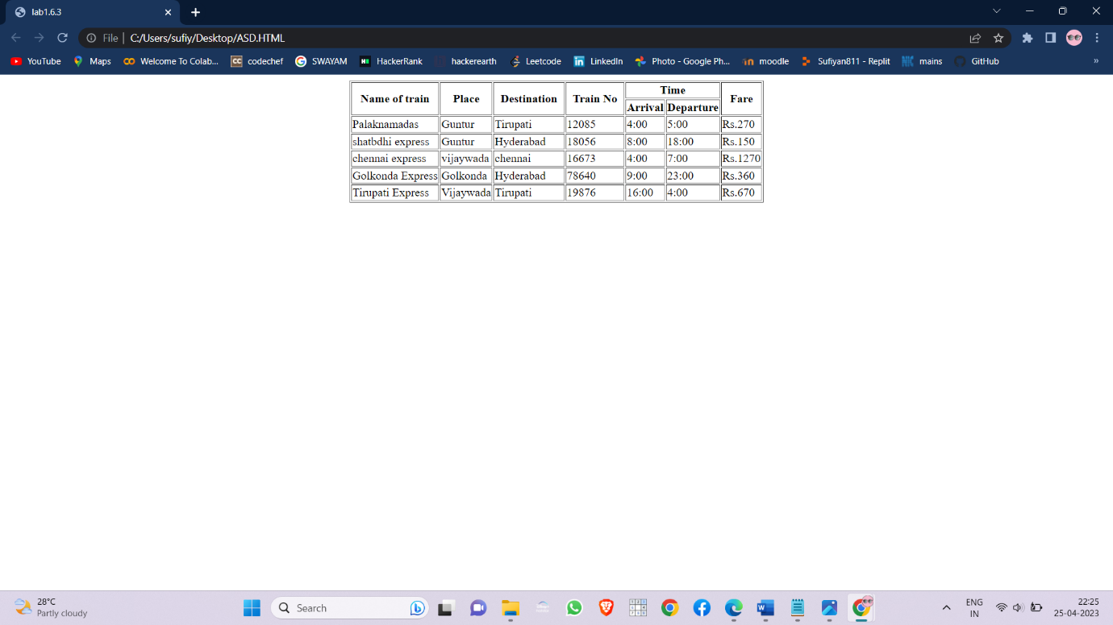

* . Create your bio-data form on a web page using all input types

SOURCE CODE:

<html>

<head><title>Biodata</title></head>

<body>

<form action="" method="POST">

<table>

<tr>

<th>Name:</th>

<td><input type="text" name="name"></td>

</tr>

<tr>

<th>Roll No.:</th>

<td><input type="text" name="id"></td>

</tr>

<tr>

<th>Date of birth:</th>

<td><input type="date" name="date"></td>

</tr>

<tr>

<th>Gender</th>

<td><input type="radio" name="gender">Male

&nbsp;

<input type="radio" name="gender">Female</td>

</tr>

<tr>

<th>Phone number:</th>

<td><input type="tel" name="phone"></td>

</tr>

<tr>

<th>Address: </th>

<td><input type="textarea" col="20" rows="4" name="addrline1"></td>

</tr>

<tr>

<th>City:</th>

<td><select name="cities" id="cities">

<option value="Select">Select</option>

<option value="Guntur">Guntur</option>

<option value="Vijayawada">Vijayawada</option>

</select>

</td>

</tr>

<tr>

<th>Email:</th>

<td><input type="email" name="email"></td>

</tr>

<tr>

<th>Local Date time:</th>

<td><input type="datetime-local" name="datetime"></td>

</tr>

<tr>

<th>IQ</th>

<td><sub>0</sub><input type="range" name="iq" min="0" max="300"><sub>300</sub></td>

</tr>

<tr>

<th>Properties</th>

<td><input type="checkbox" name="pro">House&nbsp;

<input type="checkbox" name="pro">Bike&nbsp;

<input type="checkbox" name="pro">Land</td>

</tr>

<tr>

<th><input type="submit" value="Submit"></th>

</tr>

</table>

</form>

</body>

</html>

OUTPUT:

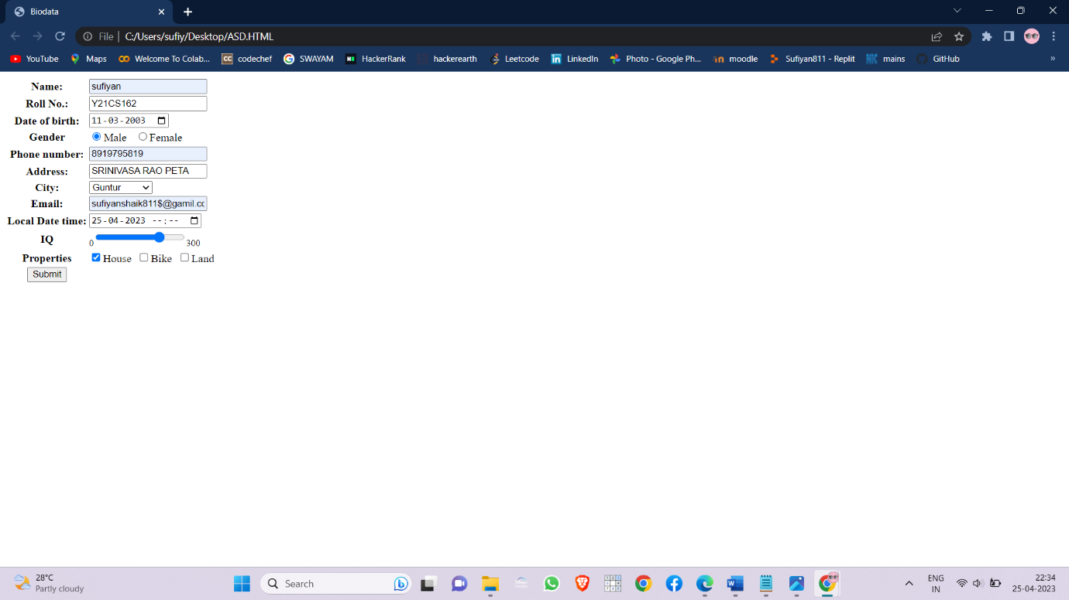

* Create a web page having radio buttons labeled as name of colours. Clicking on each radio button should change the colour of the Web page

SOURCE CODE:

<html">

<head><title>Background Colors</title></head>

<body>

<h4>Select a color:</h4>

<input type="radio" name="color”

onclick="document.bgColor='red'" >Red &nbsp;

<input type="radio" name="color" onclick="document.bgColor='blue'"> Blue &nbsp;

<input type="radio" name="color" onclick="document.bgColor='yellow'"> Yellow &nbsp;

<input type="radio" name="color" onclick="document.bgColor='orange'"> Orange &nbsp;

</body>

</html>

OUTPUT:

|  |  |
| --- | --- |
|  |  |

* Embed Audio and Video into your web page

SOURCE CODE:

<html>

<head><title>lab1.8.c</title></head>

<body>

<center>

<h1>RCB<br></h1>

<audio controls>

<source src="audio.mp3" type="audio/mpeg">

</audio><br>

<video height="440" weight="200" autoplay muted>

<source src="video.ogg" type="video/ogg">

</video>

</center>

</body>

</html>

OUTPUT:

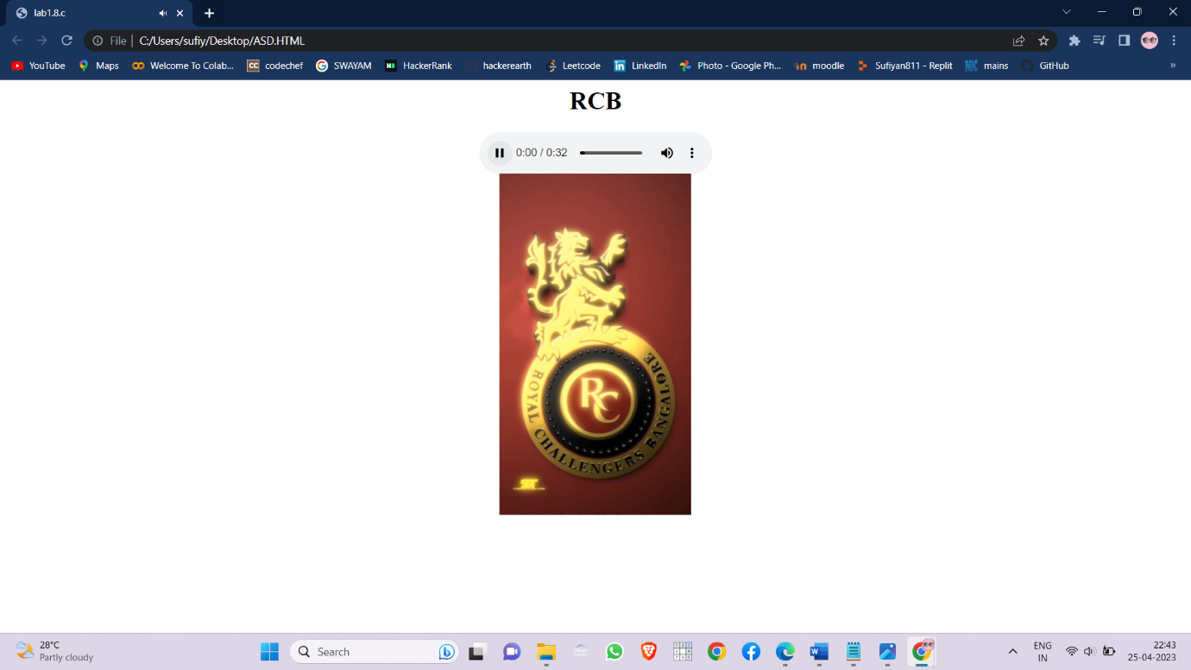

1. Create a webpage which displays the class time table and apply the following effects on the table:

a. For the table header apply blue as the background colour and white for the colour of the text in the table header.

b. Display days in a week (Mon, Tue etc...) in bold format with the first letter in the day name in uppercase.

c. Display lunch slightly in bigger font other than the remaining text.

SOURCE CODE:

html>

<head><title>Web Technologies</title></head>

<body bgcolor:"AliceBlue">

<font size="6">

<center><b><u>COMPUTER SCIENCE<br>SECTION-C</u></b></font>

<br><br><br><b><font size="5"><u>Time-Table</b></center></font></u><br>

<table bgcolor="white" border="2" align="center">

<tr style="height:50px">

<th bgcolor="blue"><font color="white">Time/Day</font></th>

<th bgcolor="blue"><font color="white">8:00 -9:00</font></th>

<th bgcolor="blue"><font color="white">9:00 -10:00</font></th>

<th bgcolor="blue"><font color="white">10:00 -11:00</font></th>

<th bgcolor="blue"><font color="white">11:00 -12:00</font></th>

<th bgcolor="blue"><font color="white">12:00 -1:00</font></th>

<th bgcolor="blue"><font color="white">1:00 -2:00</font></th>

<th bgcolor="blue"><font color="white">2:00 -3:00</font></th> </tr>

<tr> <td><b>Mon</b></td>

<td>E&H</td>

<td>CS</td>

<td>DBMS</td>

<td rowspan="6"><font size="6">L<br>U<br>N<br>C<br>H</font></td>

<td>OS</td>

<td>WT</td>

<td>SE</td> </tr>

<tr> <td><b>Tue</b></td>

<td>OS</td>

<td>WT</td>

<td>CS</td>

<td colspan="3"> WT LAB(ACC) </td> </tr>

<tr> <td><b>Wed</b></td>

<td colspan="3"> DBMS LAB(ACC) </td>

<td>CS</td>

<td>SE</td>

<td>DBMS</td> </tr>

<tr> <td><b>Thu</b></td>

<td colspan="2"> SOC LAB(E-Learning) </td>

<td>WT</td>

<td>DBMS</td>

<td>SE</td>

<td>E&H</td> </tr>

<tr> <td><b>Fri</b></tb>

<td>SOC</td>

<td>OS</td>

<td>WT</td>

<td colspan="3"> CS LAB(ACC) </td> </tr>

<tr> <td><b>Sat</b></td>

<td colspan="2"> CC LAB(E-Learning) </td>

<td>SOC</td>

<td>OS</td>

<td>CS</td>

<td>DBMS</td> </tr>

</table>

</body>

</html>

OUTPUT:

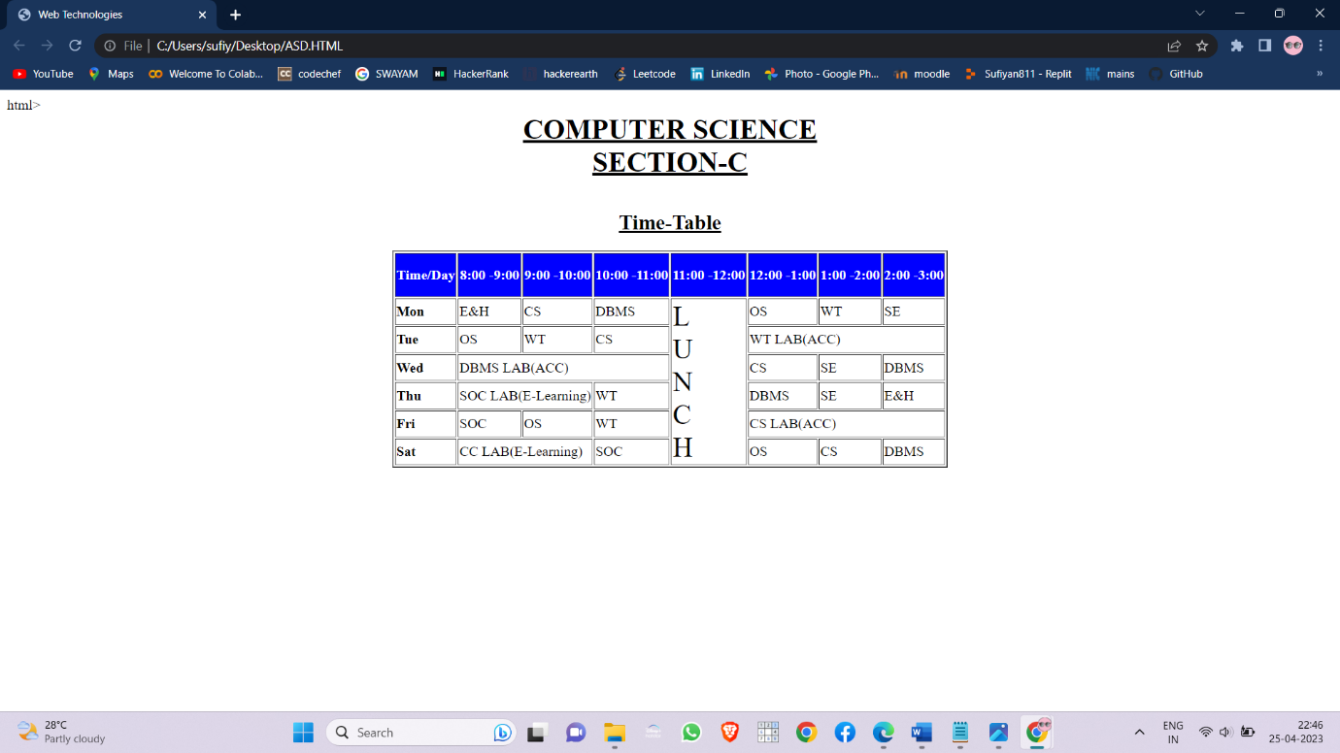

* Create a webpage which displays "Hello World" with font size 20 pixels, bold format, in "Times New Roman" font and green in colour using
* inline CSS

SOURCE CODE:

<html>

<head><title>lab.1.10.a.1</title></head>

<body>

<font size="20px" color=”green”>Hello World</font>

</body>

</html>

OUTPUT:

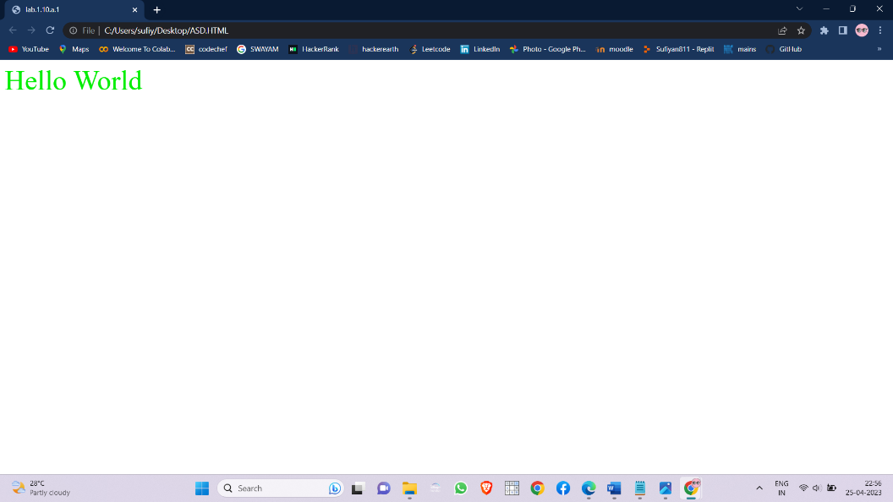

* embedded CSS

SOURCE CODE:

<html>

<head><title>lab.1.10.a.2</title>

<style>

p{

font-size:20px;

color:green;

}

</style>

</head>

<body>

<p>Hello World</p>

</body>

</html>

OUTPUT:

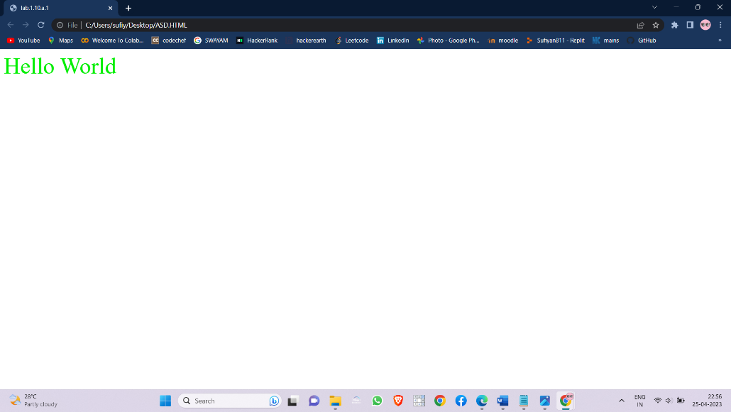

* external CSS

SOURCE CODE:

.css file

html{

height:100%;

width:100%;

}

p{

font-size:20px;

color:green;

}

.html file

<html>

<head><title>lab.1.10.a.3</title>

<link href="lab1_10_a.css" rel="stylesheet" type="text/css" />

</head>

<body>

<p>Hello World</p>

</body>

</html>

OUTPUT:

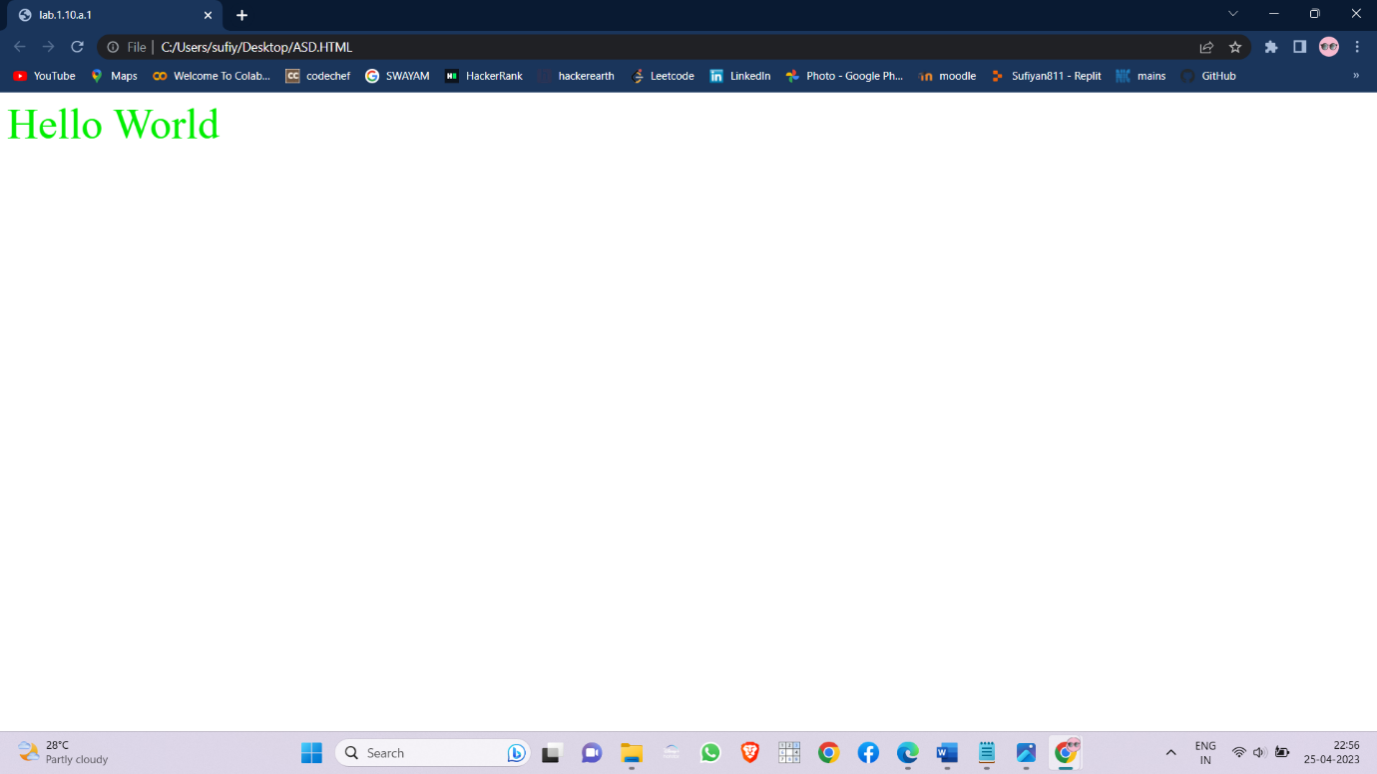

* Create a web page containing two images, where one image overlaps another image by using the z-index CSS property.

SOURCE CODE:

<html>

<head><title>lab1.10.b</title>

<style>

img{

width: 40em;

height: 20em;

position: absolute;

}

.up{

z-index:3;

left:50px;

top:150px;

}

.down{

z-index:-5;

left:300px;

top:180px;

}

</style>

</head>

<body bgcolor="green">

<h1><center>RVR & JC</center></h1>

<img class="up" src="rvrup.jpg" alt="UP Image">

<img class="down" src="rvrdown.png" alt="DOWN Image">

</body>

</html>

OUTPUT:

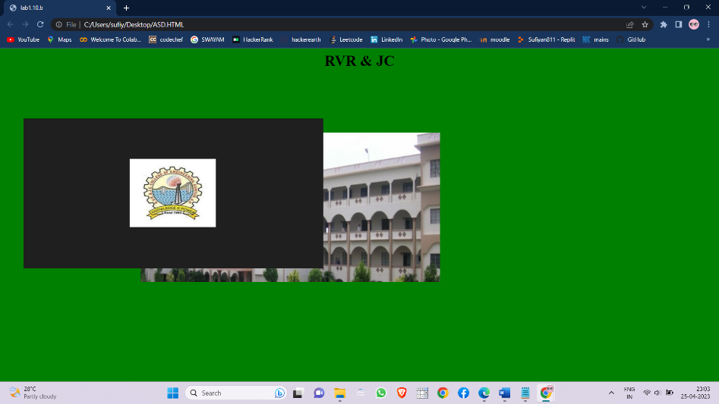

* . Demonstrate the usage of CSS Inheritance and Specificity with an example.

SOURCE CODE:

<html>

<head><title>lab1.10.c</title>

<style>

p{

font-size:50px;

color:red;

}

.p1{

font-size:inherit;

color:blue;

}

.p2{

font-size:20px;

color:inherit;

}

</style>

</head>

<body>

<p>Hello there</p><br>

<p class="p1">This is inherit</p>

<p class="p2">Example</p>

</body>

</html>

OUTPUT:

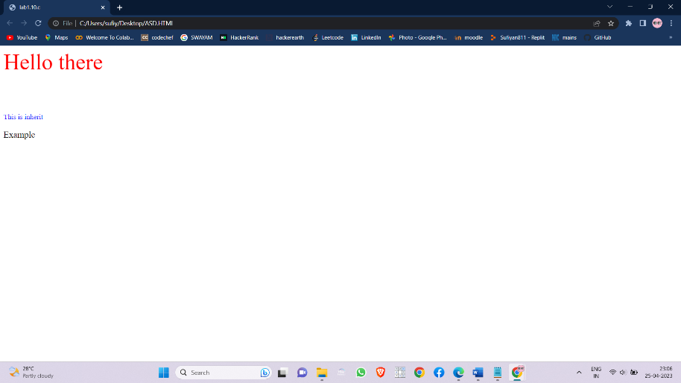

* Create a div element with a width and height of 500px. Create a diagonal linear gradient using the colors of the rainbow—Red, Orange, Yellow, Green, Blue, Indigo, Violet. (Linear Gradient)

SOURCE CODE:

<html>

<head><title>lab1_11_a</title>

<style>

div{

font-size:5em;

width:500px;

height:500px;

text-align:center;

padding:5px 25px;

background:linear-gradient(45deg,Red, Orange, Yellow, Green, Blue, Indigo, Violet);

}

</style>

</head>

<body>

<br><br><br><br>

<center>

<div>Rainbow</div>

</center>

</body>

</html>

OUTPUT:

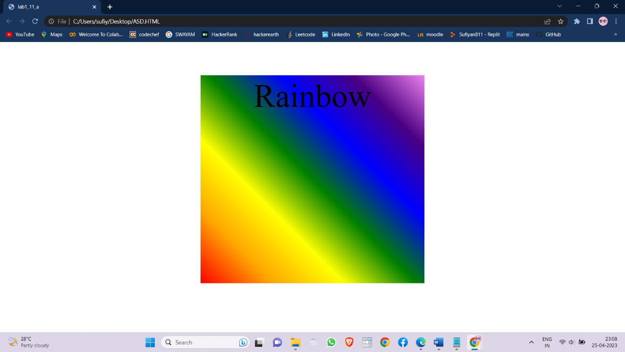

* Create a div element with a width and height of 500px. Create a radial gradient with three colors. Start the gradient in the bottom-left corner with the colors changing as they move along the gradient line to the right. (Radial Gradient)

SOURCE CODE:

<html>

<head><title>lab1_11_a</title>

<style>

div{

font-size:5em;

width:500px;

height:500px;

text-align:center;

padding:5px 25px;

background:radial-gradient(at bottom left, Yellow, Green, Blue);

}

</style>

</head>

<body>

<br><br><br><br>

<center>

<div>Radial gradient</div>

</center>

</body>

</html>

OUTPUT:

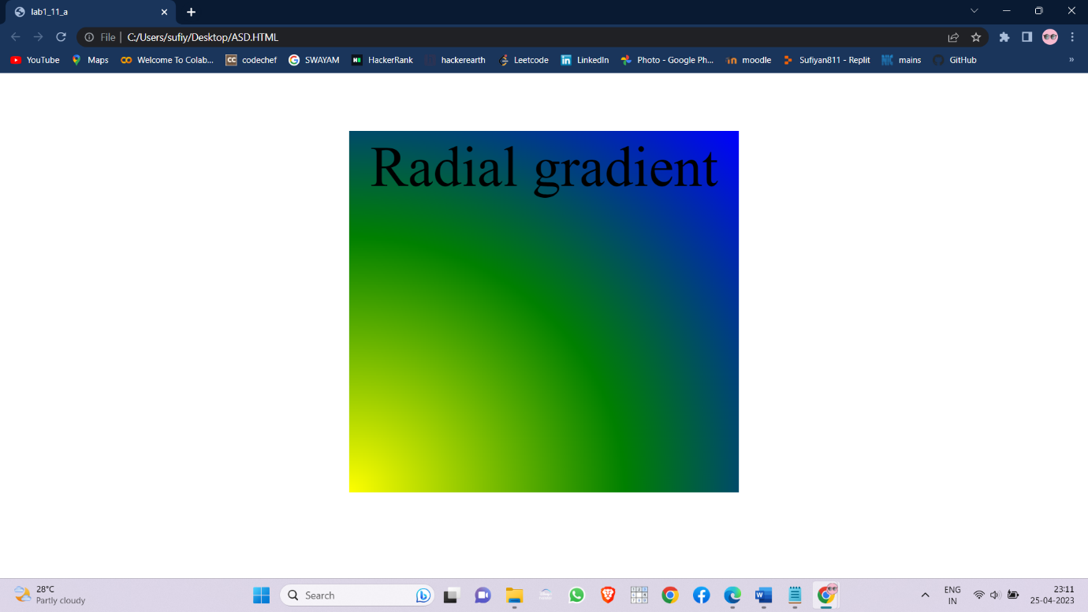

* Create an infinite animation of an element moving in a square pattern. (Animation)

SOURCE CODE:

<html>

<head>

<title>lab1_11_c</title>

<style>

div{

width: 600px;

height: 600px;

border: 1px solid black;

}

#ball {

position: absolute;

width: 100px;

height: 100px;

background-color: royalblue;

border-radius: 50px;

animation: anim 5s linear infinite;

}

@keyframes anim {

0% { left: 0px; top: 0px;}

25% { left: 500px; top: 0px; }

50% { left: 500px; top: 500px; }

75% { left: 0px; top: 500px; }

100% { left: 0px; top: 0px;}

}

</style>

</head>

<body>

<div>

<p id="ball"></p>

</div>

</body>

</html>

OUTPUT:

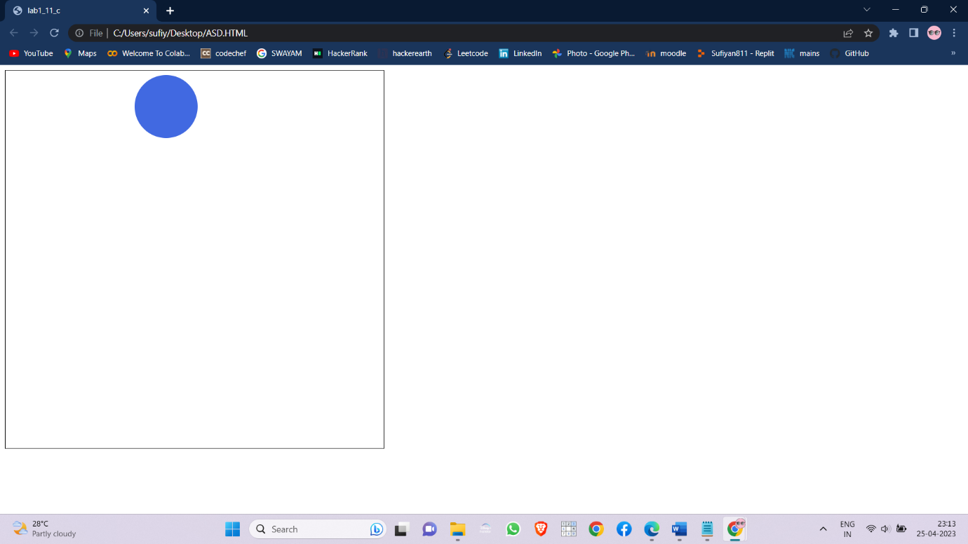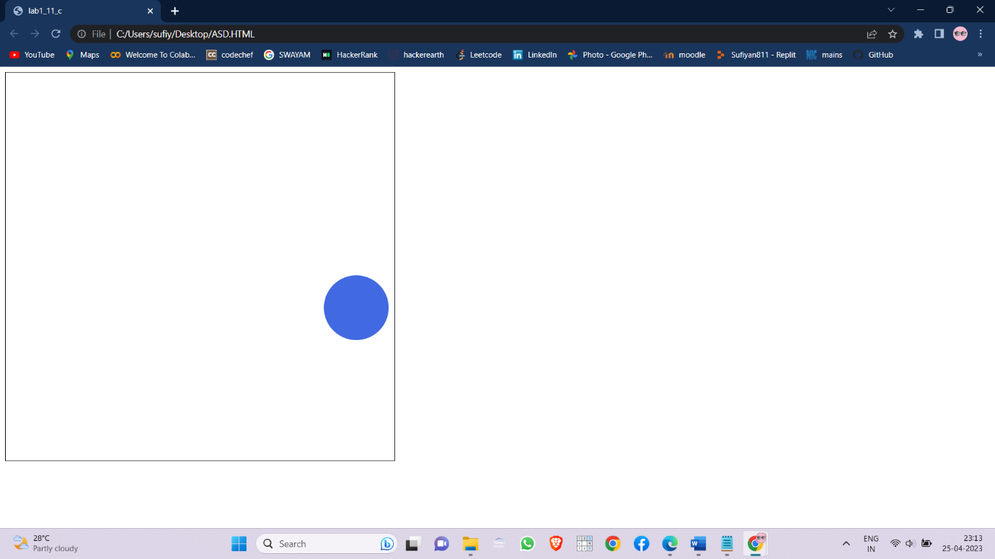

**LAB CYCLE-2:**

1. Write a java scripts to

* find the given year is leap year or not

SOURCE CODE:

<html>

<head><title>lab2_1_a</title>

<script>

var year=prompt("Enter the year : ");

year=parseInt(year);

if(year%4==0 && year%100!=0)

{

alert(year+" is leap year.");

}

else{

alert(year+" is not a leap year.");

}

</script>

</head>

<body>

</body>

</html>

OUTPUT:

|  |  |
| --- | --- |
|  |  |

* compute the biggest of three numbers

SOURCE CODE:

<html>

<head><title>lab2_1_b</title>

<script>

var num1=prompt("Enter the 1st number : ");

num1=parseInt(num1);

var num2=prompt("Enter the 2nd number : ");

num2=parseInt(num2);

var num3=prompt("Enter the 3rd number : ");

num3=parseInt(num3);

if(num1>num2 && num1>num3)

{

alert(num1+" is bigger of three numbers");

}

else if(num2>num3){

alert(num2+" is bigger of three numbers");

}

else{

alert(num3+" is bigger of three numbers");

}

</script>

</head>

<body>

</body>

</html

OUTPUT:

|  |  |
| --- | --- |
|  |  |

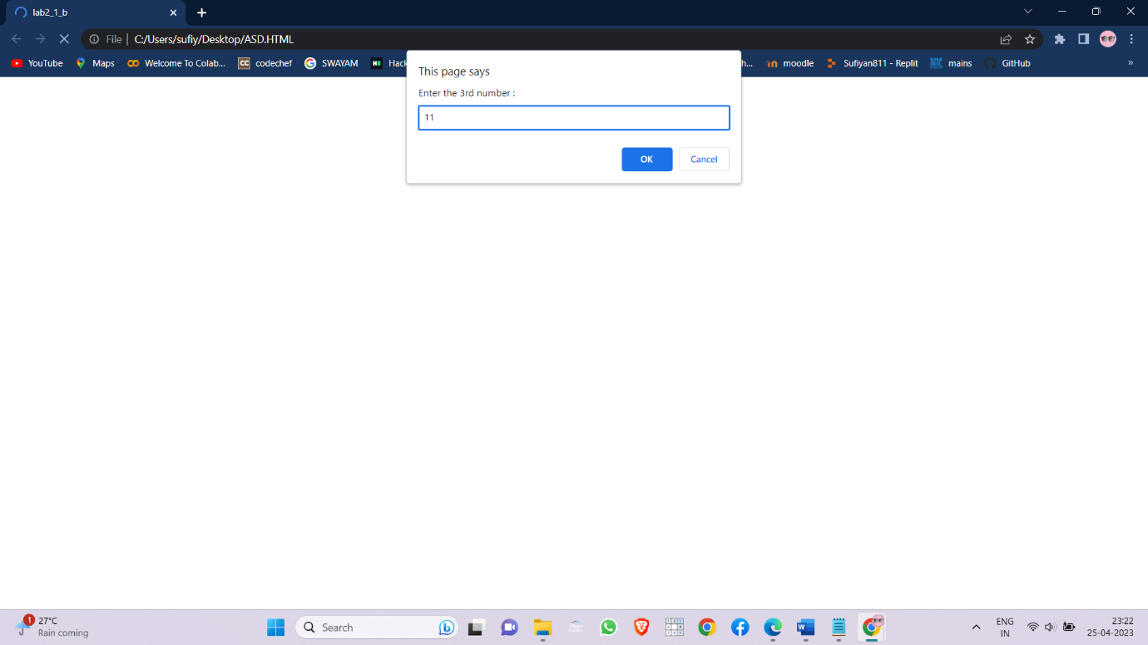

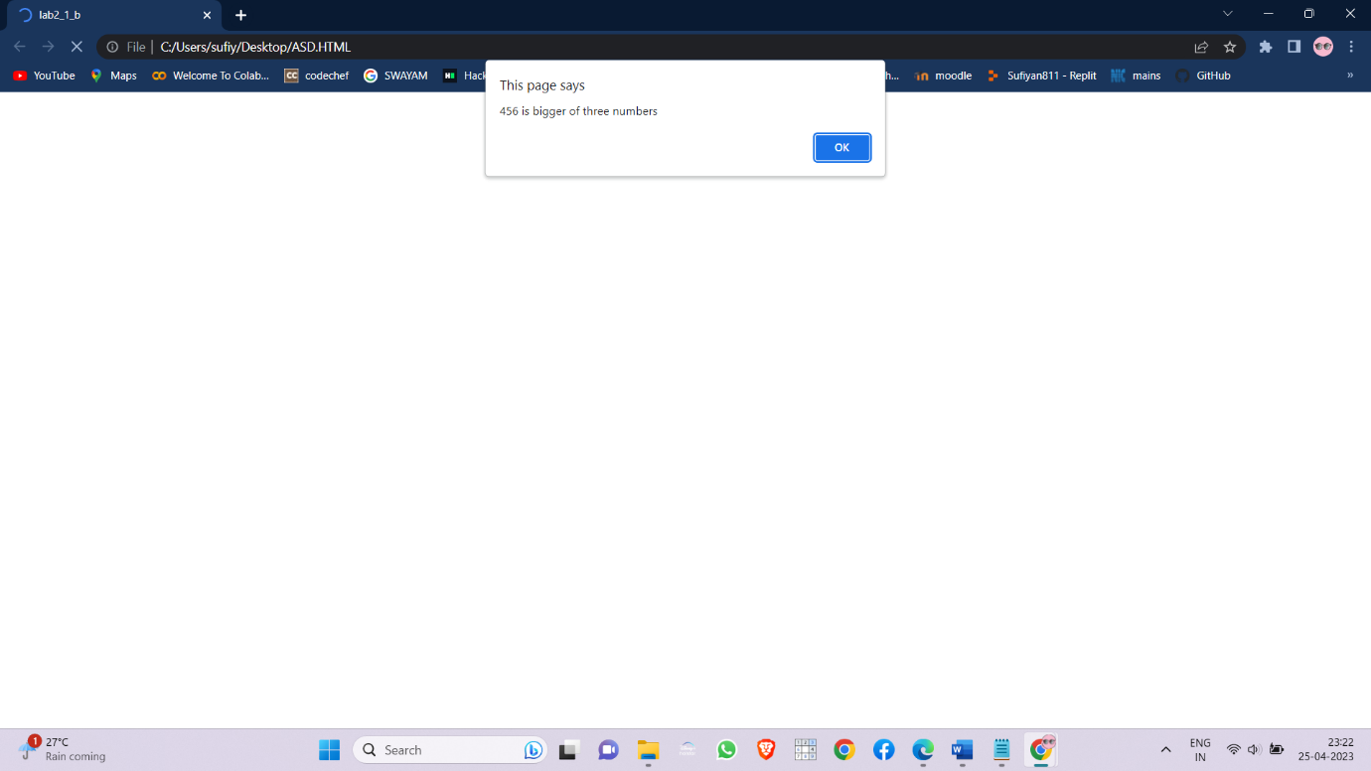

* perform the arithmetic operations using switch statement.

SOURCE CODE:

<html>

<head><title>lab2_1_c</title>

<script>

var num1=prompt("Enter the 1st number : ");

num1=parseInt(num1);

var num2=prompt("Enter the 2nd number : ");

num2=parseInt(num2);

var op=prompt("Enter the opeartor : ");

var res=0;

switch(op){

case "+":

res=num1+num2;

break;

case "-":

res=num1-num2;

break;

case "*":

res=num1*num2;

break;

case "/":

res=num1/num2;

break;

}

document.write("Numbers : "+num1+" "+num2+"<br> operator : "+op+"<br> Result : "+res);

</script>

</head>

<body>

</body>

</html>

OUTPUT:

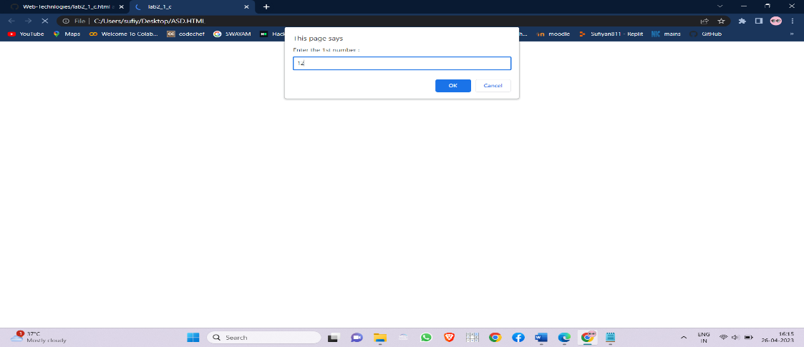

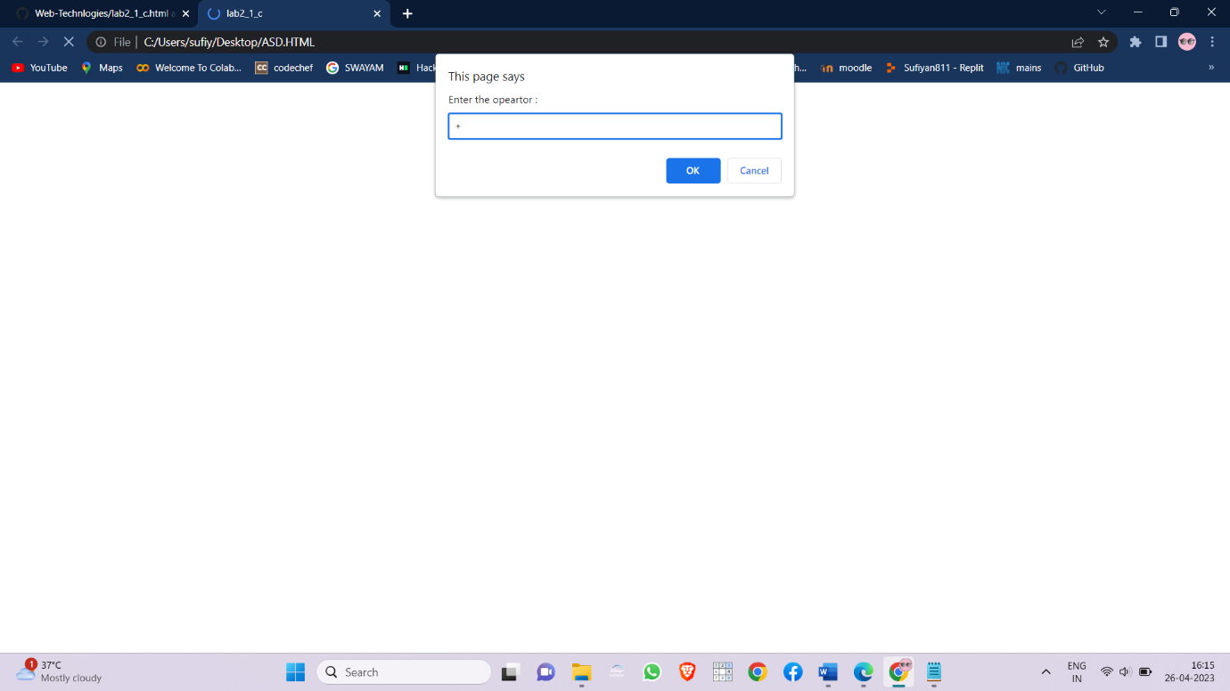

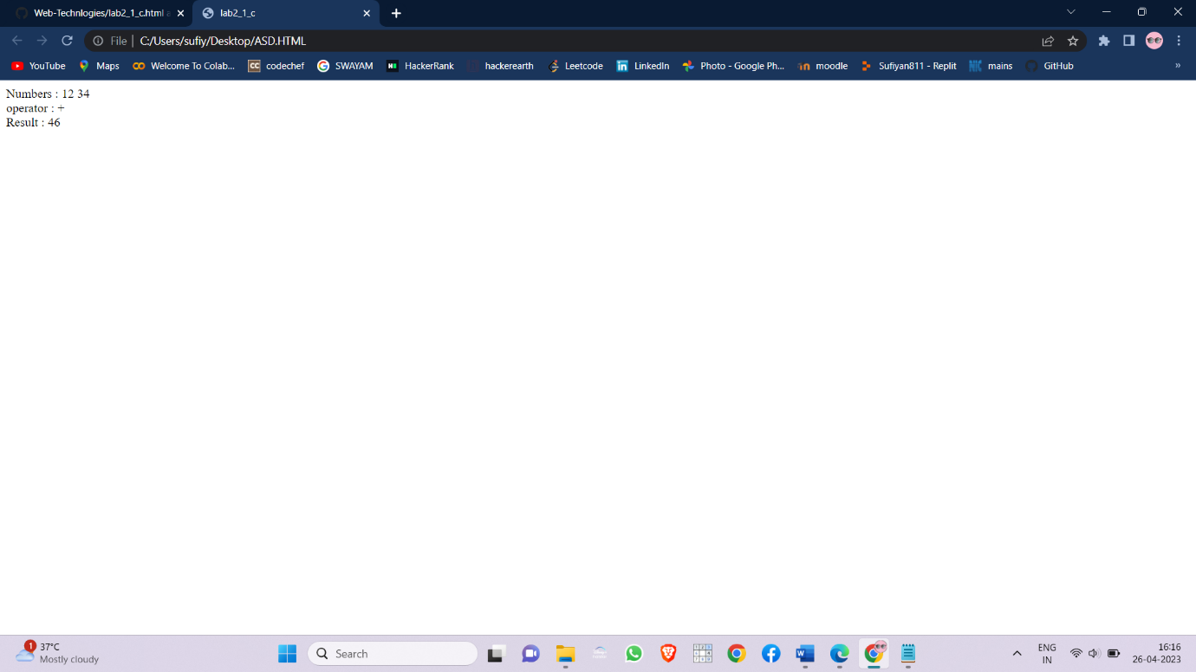

1. Write a java script to

* calculate the sum of the digits of a give number.

SOURCE CODE:

<html>

<head><title>lab2_1_b</title>

<script>

var num1=prompt("Enter the 1st number : ");

num1=parseInt(num1);

var num2=prompt("Enter the 2nd number : ");

num2=parseInt(num2);

var res=num1+num2;

document.write("<h1>Sum of "+num1+" and "+num2+" is "+res);

</script>

</head>

<body>

</body>

</html>

OUTPUT:

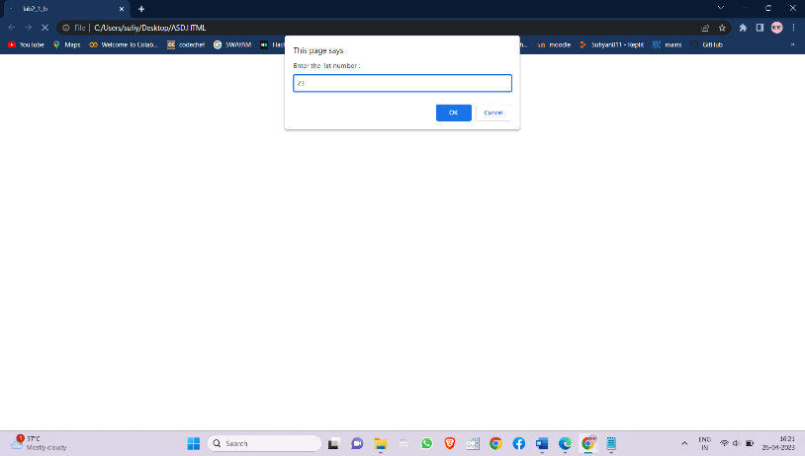

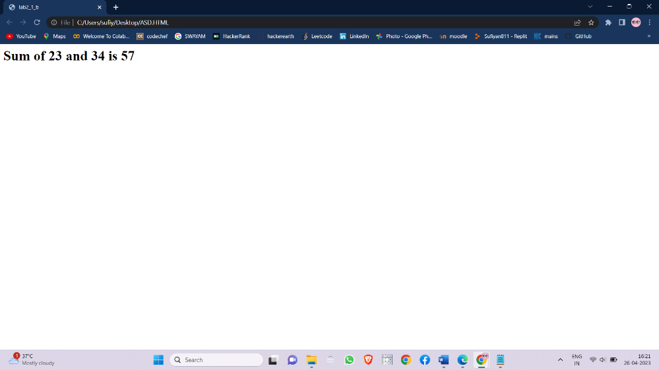

* reverse of a given number.

SOURCE CODE:

<html>

<head><title>lab2_2_b</title>

<script>

var num=prompt("Enter the number : ");

num=parseInt(num);

var rev=0;

var pre=num;

var rem;

while(num>=1){

rem=num%10;

rev=rev*10+rem;

num=parseInt(num/10);

}

document.write("<h1>Reverse of "+pre+" is "+rev+"</h1>");

</script>

</head>

<body>

</body>

</html>

OUTPUT:

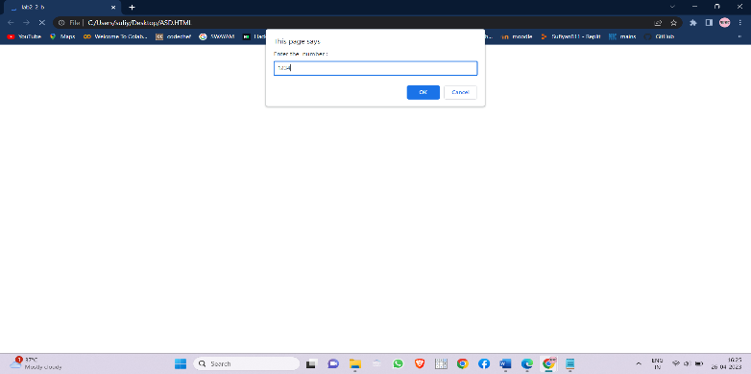

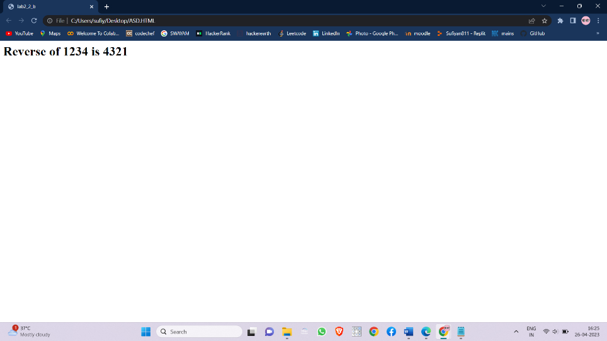

* print the first 10 natural numbers except 5

SOURCE CODE:

<html>

<head><title>lab2_2_c</title>

<script>

for(var i=1;i<=10;i++){

if(i!=5){

document.write(i+"<br>");

}

}

</script>

</head>

<body>

</body>

</html>

OUTPUT:

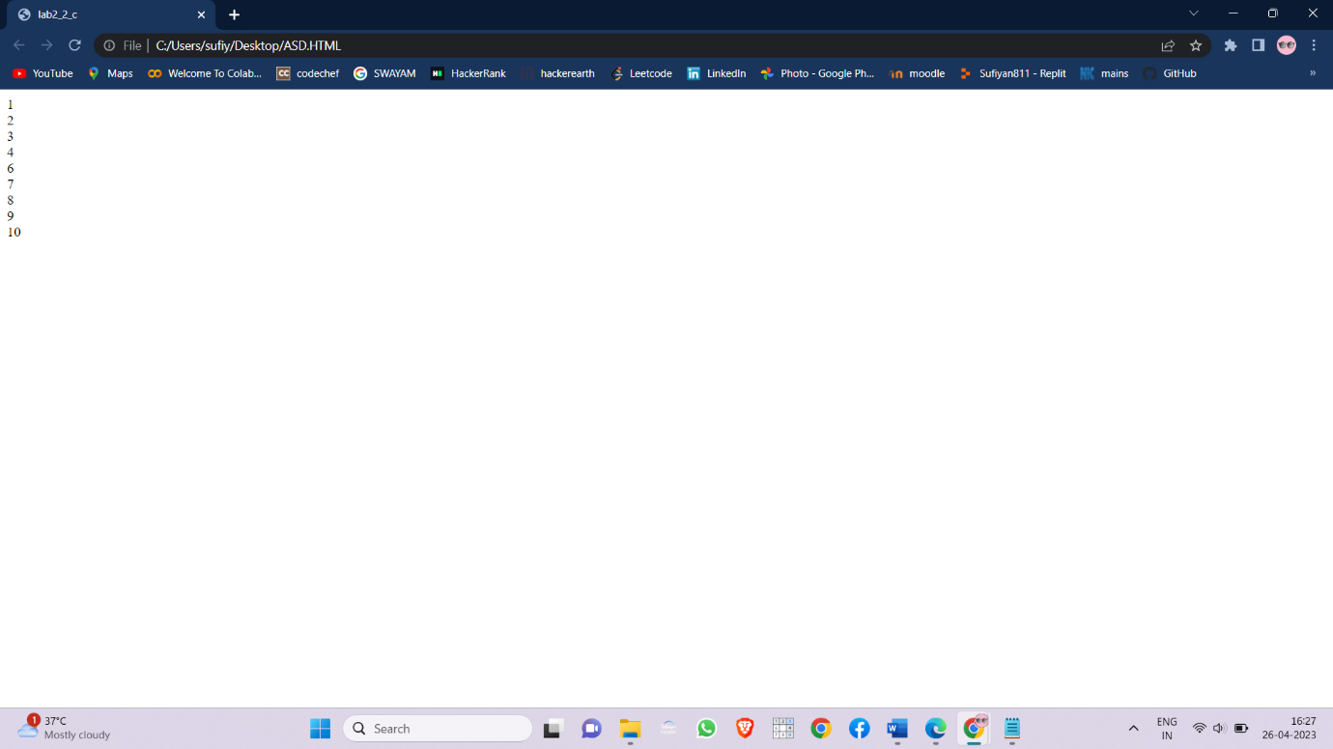

1. Write a java script to

* Functions:

1. GCD

SOURCE CODE:

<html>

<head><title>lab2_3_a</title>

<script>

function GCD(a,b){

var rem;

rem=a-(parseInt(a/b)*b);

if(rem==0){

return b;

}

else{

GCD(b,rem);

}

}

var num1=prompt("Enter the 1st number : ");

var num2=prompt("Enter the 2nd number : ");

num1=parseInt(num1);

num2=parseInt(num2);

var gcd=GCD(num1,num2);

document.write("GCD of "+num1+" and "+num2+" is "+gcd);

</script>

</head>

<body>

</body>

</html>

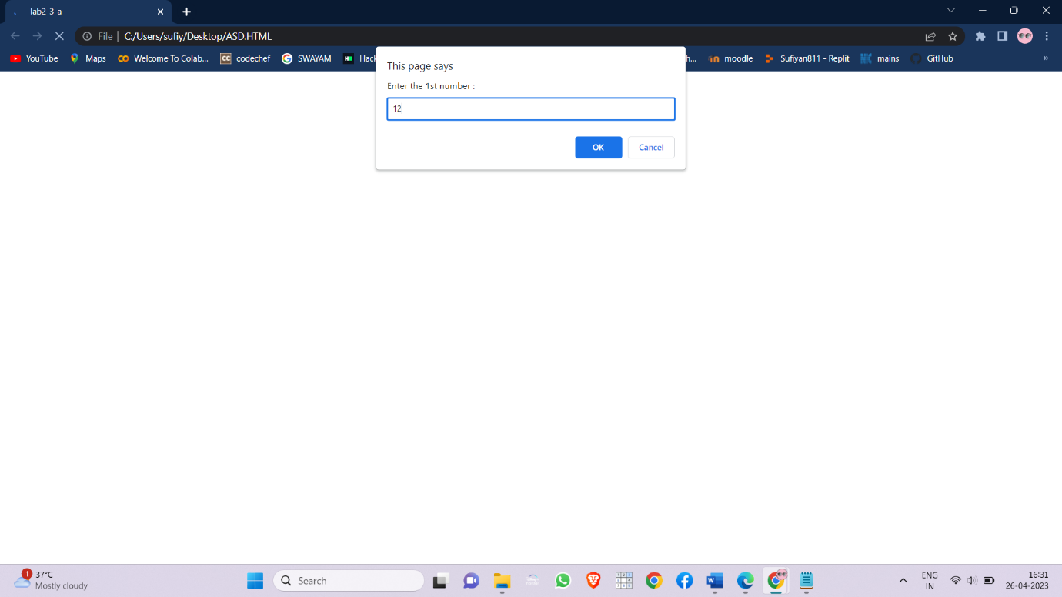

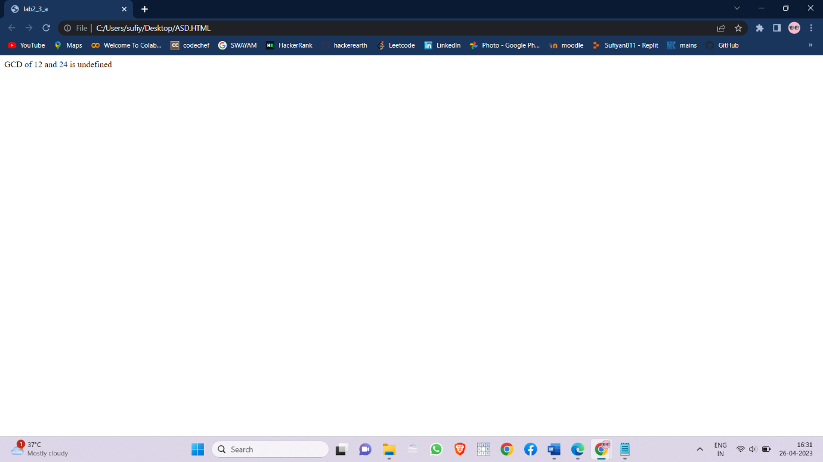

1. Reverse

SOURCE CODE:

<html>

<head><title>lab2_3_a</title>

<script>

function reverse(num){

var res=0,rem;

while(num>=1){

rem=num%10;

res=res*10+rem;

num=parseInt(num/10);

}

return res;

}

var num=prompt("Enter the number : ");

num=parseInt(num);

var rev=reverse(num);

document.write("<h1>Reverse of "+num+" is "+rev+”<h1>”);

</script>

</head>

<body>

</body>

</html>

OUTPUT:

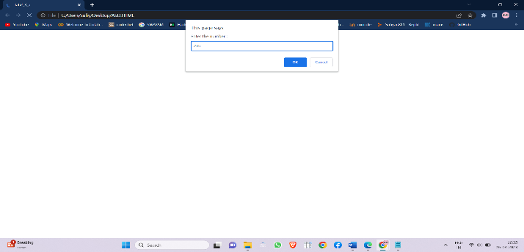

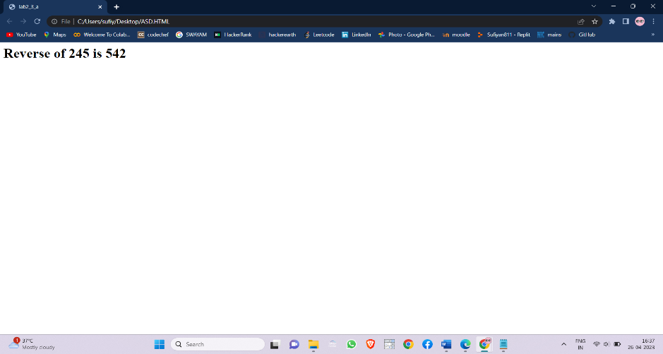

1. random numbers

SOURCE CODE:

<html>

<head><title>lab2_3_a</title>

<script>

function rand(){

var num=Math.floor(Math.random()*10);

return num;

}

var res=rand();

document.write("Random number generated : "+res);

</script>

</head>

<body>

</body>

</html>

OUTPUT:

